Cogent basics

Table of contents
- Signing in - p.2
- Media Analysis View – p.3
  - Left-hand side – p.3
- Relevant / Irrelevant / Not Processed articles – p.3
- Date filter – p.4
- Columns – p.4
- Column actions – p.5
- Search – p.6
  - Centerfold – p.7
- Translation – p.8
- Keywords – p.8
- Editing articles – p.8
- Entity mentions – p.10
  - Right-hand side – p.10
- Sentiment analysis – p.10
- Message tree – p.10
- Custom categories – p.11
- Spokespeople & Commentators – p.11

In brief: Cogent is the platform we use to analyse the media conversation (i.e. to establish what is driving the coverage and to discover how the client is being represented in the media discussion) or to monitor the media conversation (i.e. to summarise articles that are mentioning the client or any topics of interest).
Cogent hosts and facilitates all analysis/monitoring projects. Each client that has chosen Commetric as their service provider has one or several dedicated projects within the Cogent environment. A project contains the raw data that we need – all articles of interest to the client with their corresponding metadata (date, author, headline, etc.). We can analyse or monitor the coverage quickly and efficiently via Cogent’s useful tools.
- Signing in:
Once you log in to Cogent, you will see the list of My Projects i.e. the projects that you will be working on. For a project to appear within the list of your projects, you have to be assigned as a user – this should be done by your project manager.
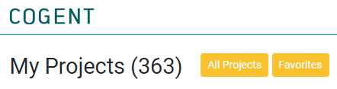
Each project has the following characteristics:
- a unique ID (which helps you locate that particular project within the Cogent environment).
- A name
- Type – the project is either a media analysis one (MA; the coverage is analysed) or a media monitoring one (Mon; the coverage is summarised).
- Project Group – each project belongs to a larger project group; some clients require the tracking of several business entities and/or topical discussions – all of these projects will fall under the same project group. For example, Centrica is a business entity that consists of several brands, including Centrica, British Gas, Bord Gais etc. The client wants us to analyse coverage about all of them, so the Centrica project, the British Gas project and the Bord Gais project are all part of the Centrica project group.
- Manager
- Articles – the number of all articles that are safe-housed in that project since its creation.
- Processed articles – articles that have been analysed.
- Remaining articles – articles that are yet to be analysed.
- Progress – ratio between processed and remaining articles.

You can mark a project as a Favourite by clicking on the star sign next to its ID. You can see all of your Favourite projects in the corresponding menu (see pic above)

- Media Analysis View:
To discover the Media Monitoring view, please refer to the Monitoring briefing.
To open a project in the Media Analysis View, click on its name in the project list.
The view consists of three sections: on the left is the list of all articles in the project; in the centre is the field with the content of the article itself, and on the right are the coding metrics that we assign to each article. The analysis is carried out via the third section of the MA view.
There are several words that all refer to “analysing” an article - “Coding”, “reading”, “processing” – you will get familiar with them as time goes on.

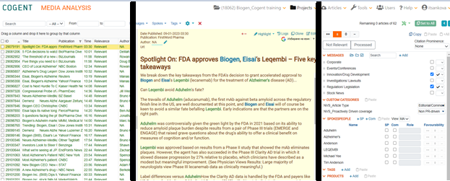
  - Left-hand side

- Relevant / Irrelevant / Not Processed articles
You currently see a list of all articles in the project. This includes articles that have been analysed (they have been deemed relevant and are coloured in green), articles that are yet to be analysed (they are not processed and are coloured in red) and articles that are not of interest for that particular project but have sneaked in for one reason or another (articles that are irrelevant and are coloured in gray). You can use the drop-down menu next to the Search in order for you to filter your view of the articles. [the drop-down menu also offers an option to filter by Processed – this is used for media monitoring so you can currently ignore it].
Relevant here means that the article has been considered relevant/meaningful in the context of this particular project according to the relevancy requirements provided by the client. Relevancy criteria are specific for each project, and the project manager is in charge of communicating them to the team.
Not processed is the “raw” article that has not yet been analysed.
Not relevant: The article has been set to not relevant, meaning that it has been considered irrelevant to the subject of the analysis, i.e., the client. For example, the client is a company called Vienna Insurance Group, but the article mentions just Vienna as the city; or the company is mentioned in a link unrelated to the focus of the project.
NB! you can see how many articles are currently visible at the bottom left side of the screen:
This number depends on the filters you have applied. If you use the drop-down menu to select, let’s say, only the Relevant articles, the number at the bottom left side of the screen will correspond to the number of Relevant articles.
If the articles are too many, Cogent could split them into pages – If you want to see all articles, you can click on the drop-down menu at the bottom and select All.
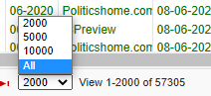
- Date filter
You can further filter the view of articles by applying a date filter. If you want to isolate only the Relevant articles for the month of April, you will select Relevant from the drop-down menu at the top and you will apply a date filter.
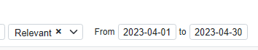
- Columns
(non-exhaustive visualisation of columns)
Each article has its own descriptors we refer to as metadata. Some of this data we receive automatically (for example the date and month of the article, the publication name, the headline), while others we fill in ourselves while analysing the coverage (for example Author name, Sentiment, Relevance). This data is situated in columns, similar to an Excel table.
- Column actions
- Clicking on a column name will sort the articles in ascending/descending order, chronologically, or alphabetically, depending on the column that you are sorting by (ID, date/time, title etc.). By default, the articles are sorted by ID in ascending order and by time and date in chronological order.
- You can rearrange the columns according to your needs by using drag and drop.
- You can also group articles by column. To do so, drag and drop a column in the field above the column names. You can group by as many columns as you want.
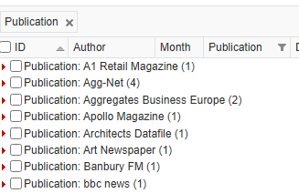
example of grouping by the Publication column
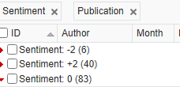
example of grouping by Sentiment and Publication. If you click on the 6 Negative articles, you can see the media sources that have published them.
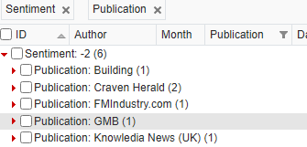
- Applying a filter to a column: You will notice that some of the columns have a filter option (little funnel next to the column name – see Publication, Sentiment). It is used to narrow down the displayed article list to your specific criteria.
For example, we may want to see a list only of the articles with positive Sentiment. To do this, click the filter of the Sentiment column and select Positive from the options, and click Apply. The little filter icon in the column will turn orange, thus indicating that this filter has been applied to the article list.
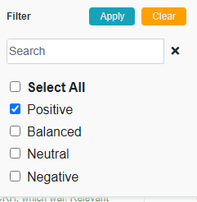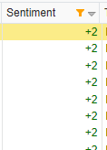

- Search
The Search works in a similar way to a Google search – you can look for mentions of a keyword or create more complex Boolean searches. The simplest search would be of a single keyword, with Cogent checking if the word is present in the headline or the body of the article. If you add an * sign after the word, Cogent will look for the word + any letters or characters after it. You can search for two words at the same time by using the operator AND. Once you run the search, Cogent will show you only the articles that adhere to the requirement. Searches do not affect all of the other filtering options, meaning you can use them in conjunction. Searches will not work if you don’t have the body of the article in Cogent.
You can also search for whole sentences if you add them in brackets (i.e. “Energy experts look to next winter as gas crisis is set to continue in 2023”). This is very useful in case of a batch (cluster) of articles –when an article has been reprinted (copied and reissued) in its entirety by several other publications, this creates a batch of articles. The content of all pieces is the same, meaning that the coding should be identical across the cluster. Using the search, you can isolate the articles and code them simultaneously using the Copy or Set to All function.
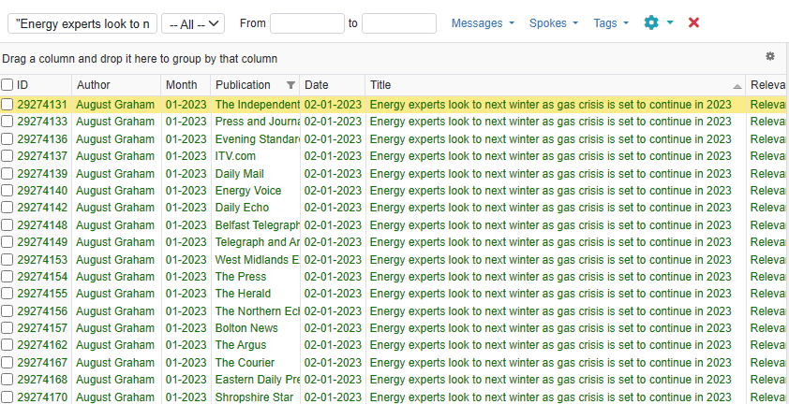

  - Centrefold
The article that is currently active is highlighted in yellow in the list of articles.
The butter yellow area in the center of the screen is the article body where all of its content is. Here, you can see the article’s content, date of publishing, publication, author, and URL, i.e., some of the metadata that is available as column names in the article list.
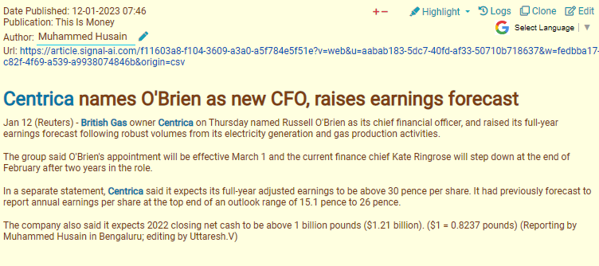
The Author field is editable and you can manually add the name of the author that has written the article. When there is no author, we usually type NA.
- Translation
On the top right of the article body, you can see the option for automated Google translation of the article’s content into English. The purpose of this functionality is to help you when working with a language that is foreign to you, as Commetric analyses media content in dozens of languages. Clicking it will display a list with all the languages available for translation.
- Keywords
Keywords are words and word combinations specific to each individual project or project group, often including, for example, the client’s name, products/services, competitors’ names/products/services, certain events, types of technologies, and so on. In the text, they are highlighted in blue (please refer to screenshot above).
For example, a project with a focus on telecommunications might include keywords such as GSM, LTE, Internet of Things (IoT), WLAN, LPWAN, security, scalability, wide area, and many others. You can add and remove keywords by clicking on the name of the project at the top of the screen, then Project Settings ‣ Keywords.
Another way to add a keyword is to double-click on it in the text. This will show a menu with several options, from which you need to select Add keyword. In the editable dialogue box that opens, confirm that this is the keyword you want to add, and click Save. As the dialogue suggests, you can add as many keywords as you like by inserting each of them on a new line.
- Editing articles
Occasionally, some articles are uploaded into the project with an empty body. This is often the case with print media articles in PDF format, as it is a bit more complex for the system to ingest them. There are two main reasons why it is more useful to have the article’s body on the platform: first, when we upload the article’s content, Cogent highlights certain project-specific keywords in it, which makes reading and skimming through the article a lot faster and easier. Second, this enables us to perform article body search and use the Boolean operators AND and OR to identify batches of articles more easily.
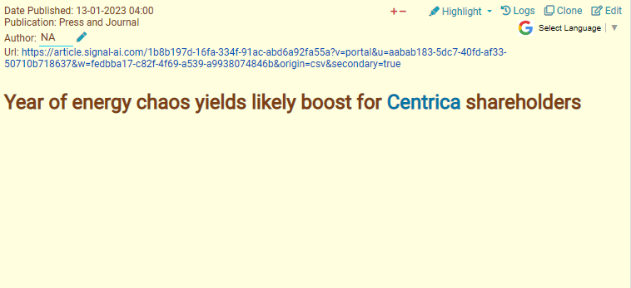An article without a body
If you want to upload the content, you can do it manually as follows:
- Click the Edit button on the top right.
- This will take you to the Edit Article view where all of the metadata fields visible in the article body view are editable.
- To upload the content of the article here, click on its URL.
- Then copy the content and paste it into the Body field.
- Tick the Run NLP box.
- Click Update.

- Entity mentions
Cogent’s NLP (Natural Language Processing) capability automatically detects entity mentions in the article body. Entities are the names of individuals featured in the article. They are highlighted in green (please refer to screenshot below). Entity detection is useful when establishing whether someone is a spokesperson or a commentator. If Cogent has not captured an individual’s name as an entity, you can add them manually by double-clicking on the name and then selecting Add spokesperson or Add commentator, depending on the case.
  - Right-hand side
In MA View, the right side of the screen is dedicated to the coding metrics that we assign to each article. The analysis is carried out via this section.
- Sentiment analysis:
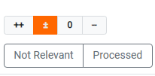
The majority of projects use four-scale sentiment coding – Positive, Balanced, Neutral or Negative. This coding gives information as to how the client is perceived by the publication.
If the client is mentioned in a positive context, the article is considered Positive (the same goes for if the article is proactive, company-driven, with a spokesperson present). If the article is overtly critical towards the client, with no response from a spokesperson or redeeming statement, the article is Negative. If there are simultaneously positive and negative mentions of the client in the article, or if the client is criticised, but has responded/has apologized, the article is Balanced. Any passing, neutral mentions or factual information are tagged as Neutral.
Under the sentiment coding tableau, you can see the Not Relevant button which marks an article as not relevant.
Once you’ve established whether the coverage is Positive, Balanced, Neutral or Negative (or Not Relevant) and you click the respective button, the article is considered analysed and will change its colour from red to green in the list of articles (left-hand side of MA View). Most projects require the coding of other metrics in addition to sentiment coding, so I would suggest considering it as the last step of the coding process.
Message tree
The message tree is employed in the most complex and time-consuming part of the analysis – the message coding. On the basis of this coding, we can establish the main focus of reporting, thus helping the client understand how it is presented in the media.
Each message tree is different and is created with the client’s objectives in mind.
The message tree is constituted of the main topical drivers of coverage as well as the messages the client wants to convey with its media presence. Some clients want to be perceived as leaders in industry debates, while others are focused on their image as a good employer. More often than not, how the client is actually perceived is completely different from how they want to be perceived.
This is why we have different types of messages we can tag in an article.
Predefined messages – provided by the client, usually vague and PR-sounding (“Our people and talent attraction”; “We are a responsible supplier who has been around a long time”)
Discovered messages – discovered by the analyst, usually client-focused & client-specific (“Centrica appoints Russell O’Brien as CFO”; “Centrica re-opens Rough gas storage facility”)
In stark difference to most other metrics, one article can have more than one message. This has a significant effect on how messages are exported via Pivot.
- Custom categories
The Custom Categories are additional metrics we are tracking in the media coverage. The key word here is the word “custom” – these metrics entirely depend on the client’s needs and are established on a project-to-project basis. Some of the more popular custom categories are Country, Media Type (Online vs Print vs Blog vs Broadcast), Proactive vs. Reactive.
CCs are similar to metrics such as Sentiment or Publication because they can only have one value – the article is either Proactive or Reactive but it definitely cannot be both at the same time. Meanwhile, messages and spokesperson & commentators can have more than one value i.e. one article can have several messages, one article can have several commentators present.
- Spokespeople & Commentators
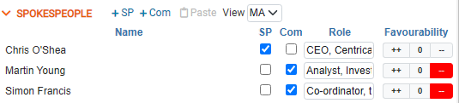
The menu is titled SPOKESPEOPLE, but it features both spokespeople & commentators coding
This is where we tag any spokespeople or commentators present in the article. A spokesperson is a company representative that has been quoted in the piece. A commentator is a third-party representative that has issued a statement in relation to the client. A mere mention does not equal a spokesperson/commentator quote – the person should be featured with a statement in order for them to qualify as a spokesperson/commentator.
Thanks to the NLP function, Cogent gives suggestions for people’s names i.e., all people coloured in green in the article body should appear under the Spokespeople coding menu as suggestions. This does not mean they are spokespeople or commentators but it’s worth checking if they are. If you want to add a name that is not present as suggestion, you can do so by clicking on the +SP or +Com button.
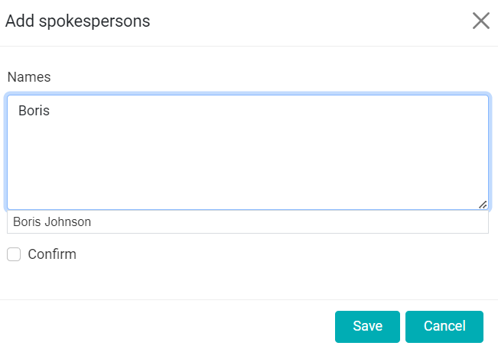
Spokespeople & Commentators have their own roles which are basically their business occupation. If the person has already been tagged as a spokes or comms in the Cogent environment, regardless if this has happened in this or any other project, the role will be filled in automatically. If not, you have to add it manually.
The only difference between Spokesperson and Commentator coding is that commentators have their own sentiment. This favourability is different from the overall sentiment coding of the article and refers to that individual’s own thoughts and opinions on the client. Commentator sentiment is coded on the Spokepeople Favourability tableau (please see pic above) and is three-scale – Positive; Neutral (which often includes Balanced comments) and Negative.

